# Agile Meets Design Thinking

## Instructions & Template for Peer-Reviewed Assignment

# NOTE: Go to the ‘File’ menu and then use either ‘Make a copy’ or ‘Download As’ to make yourself an editable copy of this template.

# What am I doing?

## Overview

For this assignment, you’ll be developing:

1. Project description
2. Brainstormed list of personas
3. Real-life examples of your top persona
4. Problem scenarios, alternatives, and value proposition trios

## Instructions

Also, as you go through these, you may want to delete the **Intro Note** and **Instructions** sections in your copy. (In Google Docs, right-click (or two-finger click on Mac) and select ‘Delete Table’.)

# 

# Part 1: Positioning Statement

## Intro Note

If you’re in the specialization, I recommend picking a concept you can build up through the courses. For example, you might have an idea to solve a problem (job, desire) you’ve had or seen, or you might want to focus on something at your current job.  ***Regardless, it's most important that the idea is relatively specific (vs. perfect) and that it’s okay for you to share it with your peer reviewers.***

## Instructions & Example

| For your product concept, just state what it does in the format you see below in ‘Assignment’. As obvious as it may seem, I find this helps with focus and collaboration- it will also help your peer reviewers better understand the balance of your assignment.  For an example, please see Appendix 1/Positioning Statement. |
| --- |

## Assignment

Introduce your the company whose product you’re working on with the positioning statement structured as follows [fill in the brackets]:

For [target customer] who [statement of the need or opportunity], the [product name] is a [product category] that [statement of key benefit – that is, compelling reason to buy]. Unlike [primary competitive alternative], our product [statement of primary differentiation].

## 

# Part 2: Brainstorm Personas

## Intro Note

You saw a few of these in action in Week 2. We’re not going to go into a lot of depth on them here, but if you want to know more here is an online tutorial: [Personas Tutorial](https://www.alexandercowan.com/tutorial-personas-problem-scenarios-user-stories/).

## Instructions

1. Spend 5 minutes brainstorming as many personas as you can. Try to generate at least 5 personas related to your area of interest. All you need to write down is a descriptive name: [Made up Name] the [Job title or role].
2. After brainstorming, sort the personas in order of priority. For example, if you could only pitch your idea to one persona, which would it be? If it’s an internal project, what user persona do you think you could help the most?
3. Finally, add a quick note on why you prioritized as you did.

| Example  | **1: Free Form Personas List- More is More Here!** | **2: List in Priority Order** | **3: Notes** | | --- | --- | --- | | Danielle the Dispatcher  Ted the Technician  Gina the Garage Manager  Mina the Shift Manager  Sven the Support Agent  Andrea the Accountant  Sal the Salesperson  Ingrid the IT Person  Vicki the Vendor Manager  Orson the Ordering Manager | Ted the Technician  Sal the Salesperson  Danielle the Dispatcher  Sven the Support Agent  Orson the Ordering Manager  Mina the Shift Manager  Ingrid the IT Person  Vicki the Vendor Manager  Gina the Garage Manager  Andrea the Accountant | Since we have the most ‘Ted’s’ working at the company and they are our primary interface to the customer, we think we have the most upside there. | |
| --- | --- | --- | --- | --- | --- | --- |

## Assignment Body

| **1: Free Form Personas List- More is More Here!** | **2: List in Priority Order** | **3: Notes (Optional)** |
| --- | --- | --- |
| [Step 1: Draft as many personas as you can think of in the form [Made up Name] the [Job title or role].] | [Step 2: Sort them in priority order. If it’s hard, just take your best guess. You can always revise it.] | Since we have the most ‘Ted’s’ working at the company and they are our primary interface to the customer, we think we have the most upside there. |

# Part 3: Make Your Persona Testable & Actionable with a Screener

## Intro Note

A good persona is vivid and testable. An effective way to make sure you’re there is to have a screener. This is (ideally) one or two questions with discrete answers where with a simple response you can qualify or disqualify a subject (individual) as representative of your persona (or not).

## Instructions

For the top persona selected in the list above, create a screener and (optionally) explain your reasoning. Remember, you’re not trying to sell them anything or convince them of anything- you’re just trying to assess whether they’re representative of your selected persona.

| Example With this particular persona, we want to make sure the individual is an HVAC technician. we need to screen out, for example, managers that do an occasional repair and also (in future investigations) generalists who repair facilities in general but aren’t focused just on HVAC.   | **Persona** | **Screening Question** | **Threshold** | | --- | --- | --- | | Ted the Technician | How many HVAC repairs did you do last week? | >3 repairs | |  |  | |
| --- | --- | --- | --- | --- | --- | --- | --- | --- |

## Assignment Body

[Notes on your reasoning for the screener]

| **Persona** | **Screening Question** | **Threshold** |
| --- | --- | --- |
| [name/description of your persona] | [screening question #1] | [threshold value] |
| [screening question #2- reminder: only use this if you need it; one question is better than two if you can make it work] | [threshold value] |

# Part 4: Develop Problem Scenario, Alternatives, Proposition Trios

## Intro Note

Here, you start to think about what’s actually important to your personas, how they’re doing that now, and how you might improve it.

## Examples

See Appendix 1/Part 4

## Instructions

For your top persona pick in the list above, think about the top problem scenarios/jobs-to-be-done in your area of interest, along with their current alternatives and your value proposition. Do at least two trios (two PS/JTBD + Alt. and VP).

## Assignment

Fill in the table below with your problem scenarios, their current alternatives, and your value proposition.

| **Problem Scenarios/Jobs-to-be-Done** | **Current Alternatives** | **Your Value Proposition** |
| --- | --- | --- |
| [INSERT- What problems, needs does the persona have in your area of interest?] | [INSERT- Instead of using your product or deliverable, what do they do right now to solve this problem/meet this need?] | [INSERT- What will you do that’s better enough than the alternatives that your target persona will buy/engage with your offer? ] |
| [add as needed] | [add as needed] | [add as needed] |
| [add as needed] | [add as needed] | [add as needed] |

# Part 5: Design a Solution for Your PS/JTBD with User Stories

## Intro Note

List at one or more epics in the section ‘Epic User Stories’. Then, pick one and detail it with a storyboard and child stories in the section Epic 1- Detail. Copy and repeat that section of the template for additional epics.

## Example

See Appendix 1/Part 5 for an example.

## Assignment

### Epic User Stories

[Epic 1 in format “As a [persona],I want to [do something] so that I can [realize a reward]”]

[Epic 2 in same format]

…

[Epic N in same format]

### Epic 1- Detail (Storyboard & Child Stories)

**Storyboard for Epic 1**

[place the storyboard you sketched for your epic here- a simple photo from your phone of a paper drawing is fine]

**Child Stories for Epic 1**

| **Child Stories** | **General Notes & Analytics** |
| --- | --- |
| [place your child stories for epic here] | [add analytical questions and (optionally) metrics] |
| [place your child stories for epic here] | [add analytical questions and (optionally) metrics] |
| [place your child stories for epic here] | [add analytical questions and (optionally) metrics] |
| [place your child stories for epic here] | [add analytical questions and (optionally) metrics] |
| [place your child stories for epic here] | [add analytical questions and (optionally) metrics] |
| [place your child stories for epic here] | [add analytical questions and (optionally) metrics] |
| [place your child stories for epic here] | [add analytical questions and (optionally) metrics] |
| [place your child stories for epic here] | [add analytical questions and (optionally) metrics] |
| [place your child stories for epic here] | [add analytical questions and (optionally) metrics] |

# Submitting Your Assignment

Remember to upload your work in ONE document (PDF format), including your:

1. Project description
2. Brainstormed list of personas
3. Real-life examples of your top persona
4. Problem scenarios, alternatives, and value proposition trios

Be sure to review the rubric to verify you have included all the necessary criteria to complete the assignment.

# 

# Appendix 1: Reference Example

## Part 1: Positioning Statement

### Intro Note

I’ve included a positioning statement for both the enterprise as a whole and the specific (internal) product the HinH team is working. I thought this enterprise statement would help with context/relevance for the product. Including a positioning statement for the enterprise/company as a whole is optional, though.

### For the Enterprise as a Whole

For [facilities managers & business owners] who [need their heating & cooling systems managed and repaired], [HVAC in a Hurry] is a [full service heating and cooling provider] that [allows for easy and responsible management of a business’ HVAC systems]. Unlike [smaller firms], our [commitment to best practices and training allows customers to worry less and realize superior total cost of ownership for their HVAC systems].

### 

### For their Digital Platform

For [dispatchers and technicians] who [work at HVAC in a Hurry], [H-ify] is an [enterprise software solution] that [improves the HVAC repair and maintenance experience for both internal staff and customers]. Unlike [ad hoc solutions], our product [has been carefully formulated and validated against best practices and awesome customer experiences out in the field].

## Part 2: Brainstorm Personas

[see assignment above]

## 

## Part 3: Make Your Persona Testable & Actionable with a Screener

[see above]

## Part 4: Develop Problem Scenario, Alternatives, Proposition Trios

NOTE: I included two here but for the assignment you should pick just one persona.

### Drafting a PS/JTBD- Example 1 (HVAC in a Hurry Salespeople- Sal the Salesperson)

| **Problem Scenarios** | **Current Alternatives** | **Your Value Proposition** |
| --- | --- | --- |
| Deciding who to call about what  Engagement Metric  [Calls made] | Various and ad hoc per salesperson via Salesforce and spreadsheets | If we accurately predict the expected value of an opportunity, then the salespeople will use our dashboard/tool and it will improve outcomes. |
| Knowing where to focus on a call  Engagement Metrics  [Pitches created] | Ad hoc based on experience and (large accounts) prior relationship | If we usefully predict and aggregate key proposition parameters, then the salespeople will use our pitch tool and it will improve outcomes. |

### Drafting a PS/JTBD- Example 2 (HVAC in a Hurry Technician- Ted the Technician)

| **Problem Scenarios** | **Current Alternatives** | **Your Value Proposition** |
| --- | --- | --- |
| Getting replacement parts to a job site  Engagement Metric  [Replacement Parts Ordered] | Call the office and request the part then wait for an update on the phone or through a call-back | If we automate parts lookup and ordering online, then the techs will use it and it will improve outcomes. |

## 

## Part 5: Design a Solution for Your PS/JTBD with User Stories

### Epic User Stories

**‘As Ted the HVAC technician, I want to know the pricing and availability of a part that needs replacing so I can decide my next steps.’**

As Ted the HVAC tech, I want to order a replacement part so I can make sure I know my next steps and timing.

‘As Ted the HVAC tech, I want to understand how to arrive at my next job prepared so I avoid logistical delays and the customer having to repeat themselves.’

‘As Danielle the Dispatcher, I want to understand a customer’s location, needs, and urgency level so I can decide who, what, and when to dispatch to their site.’

‘As Danielle the Dispatcher, I want to see a specific technician’s availability so I can decide whether I’m able to use them for follow-up on a job they started.’

### Epic 1- Detail

Epic 1 is: ‘As Ted the HVAC technician, I want to know the pricing and availability of a part that needs replacing so I can decide my next steps.’

### 

### Storyboard

Please note: This was created with a tool, but a simple pencil/paper drawing is *fine*.

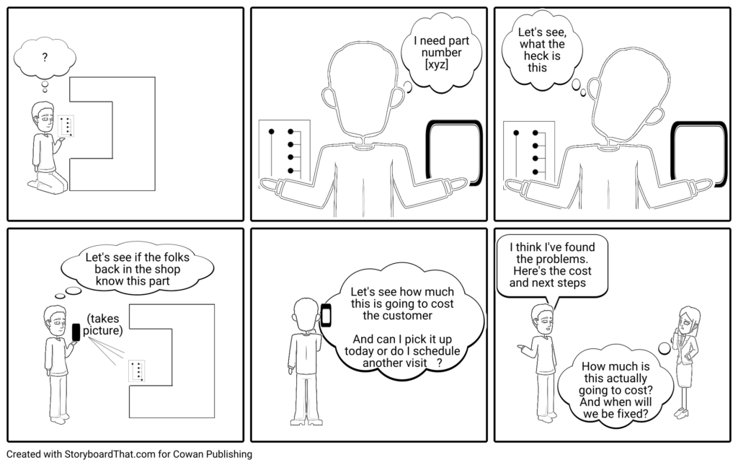

### Child Stories

| **Child Stories** | **General Notes & Analytics** |
| --- | --- |
| I know the part number and I want to find it on the system so I can find out its price and availability. | How well does this search type work relative to the alternatives?  How often is this search used per transaction relative to the alternatives?  Metrics:  Searches of this type relative to others  Sequence of this search relative to other search types  Conversion to order from this type of search (%) |
| I don’t know the part number and I want to try to identify it online so I can find out its price and availability. | (see above) |
| I don’t know the part number and I can’t determine it and I want help so I can find out its price and availability. | (see above) |
| I want to see the pricing and availability of the part so I decide on next steps and get agreement from the customer. | How often does this lead to a part order?  How well do techs that do this perform relative to others?  Metrics:  Conversion rate to order  Customer satisfaction per job of tech’s in a cohort that use the tool vs. baseline (mean customer satisfaction per job)  Billable hours for tech’s in this cohort vs. baseline (billable hours per week) |